Write a program for Minimax algorithm for gaming using python code

Aim :To implement the Minimax Algorithm for game playing in Python.
Procedure:
Define a recursive Minimax function.
Check if the current node is a leaf node.
If it is the maximizing player's turn, choose the maximum value.
If it is the minimizing player's turn, choose the minimum value.
Return the optimal value for the root node.

Output:
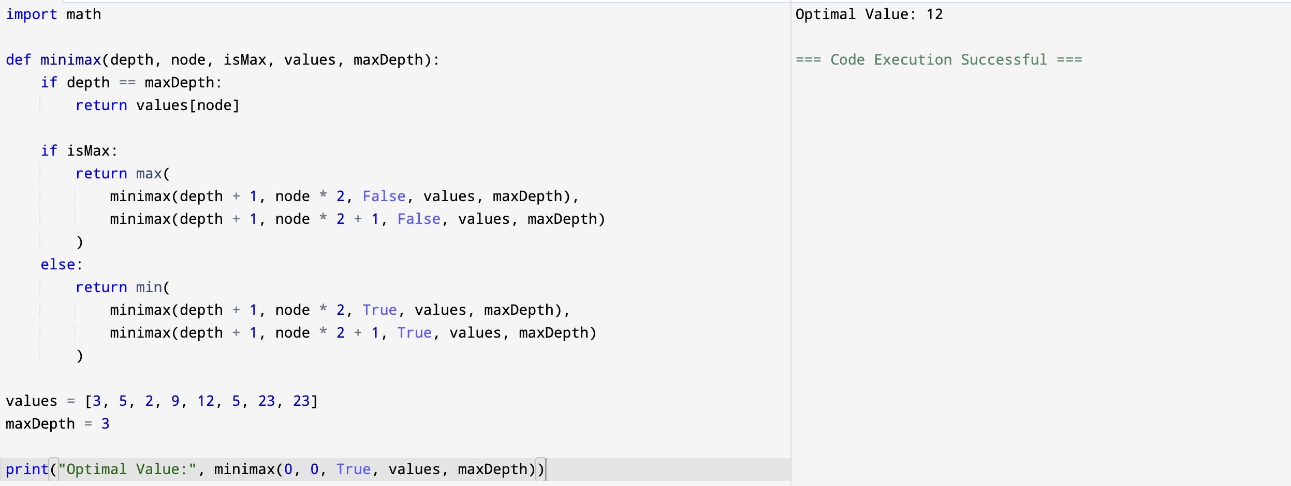

Result: Hence, Minimax problem for gaming has been solved

